**Lecture: EFS Fundamentals: Part 1**

The Elastic File System (EFS) is an AWS-managed implementation of the Network File System (NFS). It's a popular shared strorage system that can be natively mounted as a file system within Linux instances. This lesson reviews the architecture of EFS and how it can be implemented within a VPC and beyond.

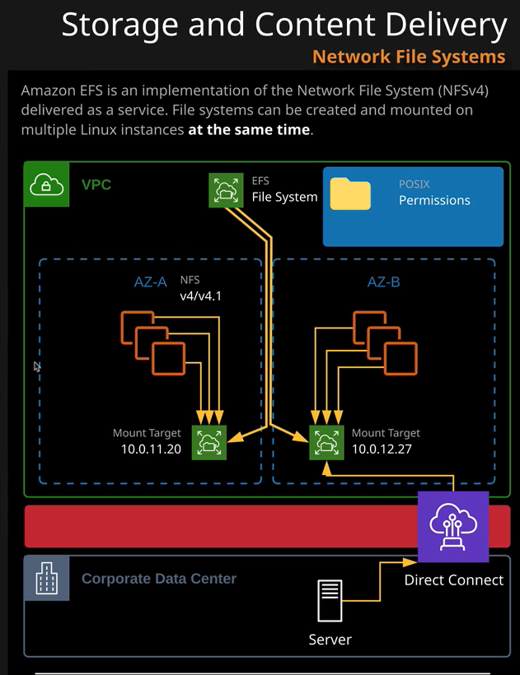

Ssh –A –I <.pem> ec2-user@jumphost 🡪 “-A” helps you to connect to multiple nodes with out asking for password.

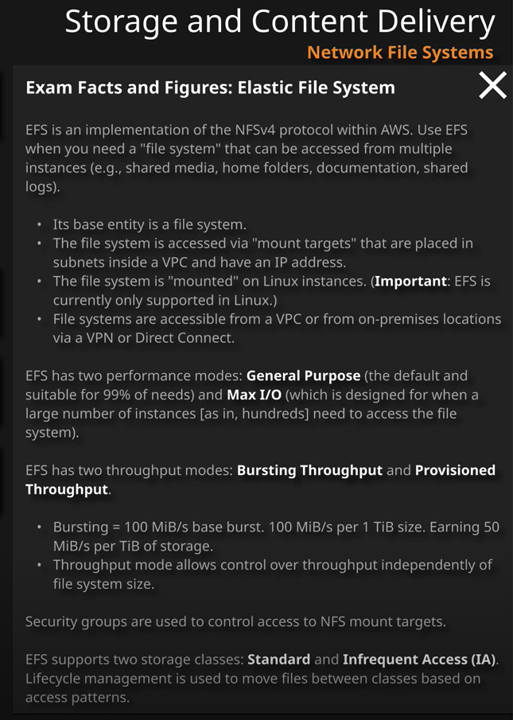

Installing and configuring EFS in Ec2 Servers:

#yum install amazon-efs-utils -y

#mkdir /mnt/efs

sudo mount -t efs -o tls fs-0ef8016a68859798e:/ efs

#mount –t efs fs-0ef8016a68859798e :/ /mnt/apps

Explain in detail about the EFS(NFS 4.0) and use case of having this as part of the system.